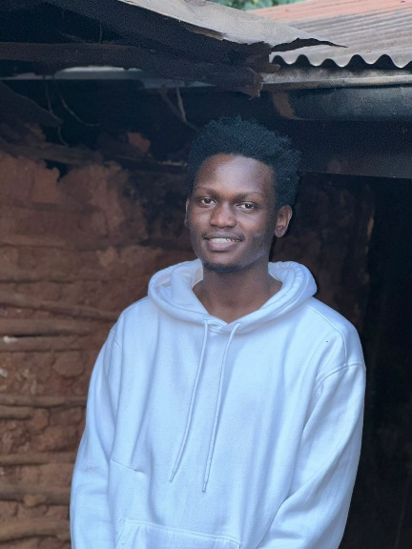

**Mishael Matende**

**Full Stack Developer**

* **Profile**

I am a passionate software developer who finds joy and excitement in developing and/or crafting products that promote functionality and design.

I am a lover of website responsiveness and the Markdown language.

I excel working both individually and, in a group, /team this is purely because group projects are the best way to get hands on experience when it comes to learning a new concept, framework or programming language. Working individual has huge benefits when it comes to the mastery of the same.

* **Skills**
* React, JavaScript, PostgreSQL, Tailwind, Bootstrap
* Website Responsiveness, HTML, Native CSS
* **Education**

**The Complete Web Development Bootcamp.**

Udemy.

2022 – 2023.

**Bachelor in Information Security and Forensics.**

KCA University.

2021 – 2023.

**Diploma in Information and Technology.**

KCA University.

2019 – 2021.

** Projects**

Portfolio Website.

<https://mishmatende.github.io/Portfolio-Website/>

<https://mishael-website.vercel.app/>

** Contact**

 [mishaelmatende@gmail.com](mailto:mishaelmatende@gmail.com)

 <https://github.com/MishMatende>